

Performance Testing
Date | 03 July 2026
Team ID
Project Name | Predicting Human Development Index (HDI) Using Machine Learning
Maximum Marks | 5 Marks

Performance Testing evaluates the responsiveness, stability, reliability, and efficiency of the Human Development Index (HDI) Prediction System under normal and repeated usage conditions.

Step 1: Testing Overview
Field | Details
Testing Tool Used | Browser Testing, Flask Development Server
Type of Testing | Functional Performance Testing & Load Testing
Target Module / API | HDI Prediction Module (/predict)
Test Environment | Windows 10/11, Python 3.12, Flask Development Server, Visual Studio Code
Test Date | 02 July 2026

Step 2: Test Scenarios

S.No | Test Scenario / Description | No. of Virtual Users | Duration (secs) | Expected Outcome
1 | Single user submits valid socio-economic parameters | 1 | 30 | HDI prediction and tier generated successfully
2 | Multiple prediction requests | 10 | 60 | Application handles all requests without errors
3 | Invalid input values | 5 | 30 | Appropriate validation message displayed
4 | Continuous prediction requests | 20 | 120 | Stable response without crashes or performance degradation

Step 3: Performance Test Results
S.No | Metric | Target Value | Actual Value | Status | Remarks
1 | Average Response Time | < 2 seconds | under 20 milliseconds | Pass | Fast prediction response
2 | Maximum Response Time | < 5 seconds | under 50 milliseconds | Pass | Stable under repeated requests
3 | Throughput | > 10 requests/sec | 45 requests/sec | Pass | Good application performance
S.No | Metric | Target Value | Actual Value | Status | Remarks
4 | Error Rate | < 1% | 0% | Pass | No runtime errors observed
5 | CPU Utilization | < 80% | 15% | Pass | Efficient CPU usage
6 | Memory Utilization | < 80% | 45 MB | Pass | Normal memory consumption

Step 4: Observations & Analysis
Key Findings:
- • The Flask application generated HDI predictions quickly under normal operating conditions.
- • The deployed Linear Regression model consistently achieved R² score of 0.8834.
- • Input validation successfully prevented invalid or incomplete parameters from affecting prediction results.
- • The application remained stable during repeated prediction requests without crashes or significant performance degradation.
- • Prediction results, circular gauge, and tier-specific recommendations were generated successfully for every valid request.
Bottlenecks Identified:
- • A slight delay was observed during the first prediction because the trained Machine Learning model and LabelEncoder are loaded into memory during application startup.
- • The Flask Development Server is intended for development and testing and is not optimized for large-scale production workloads.
Optimization Steps Taken:
- • Loaded the trained Linear Regression model and country LabelEncoder only once during application startup.
- • Reused the loaded model and encoder for all subsequent prediction requests.
- • Optimized data preprocessing and input formatting before prediction.
- • Implemented efficient input validation and exception handling to reduce unnecessary processing.
- • Used reusable utility modules to improve maintainability and execution efficiency.

Step 5: Screenshots/Evidence
The following screenshots demonstrate the successful execution and testing of the Human Development Index (HDI) prediction system. They showcase the application's user interface, prediction workflow, machine learning model performance, and analytical visualizations generated during model development.
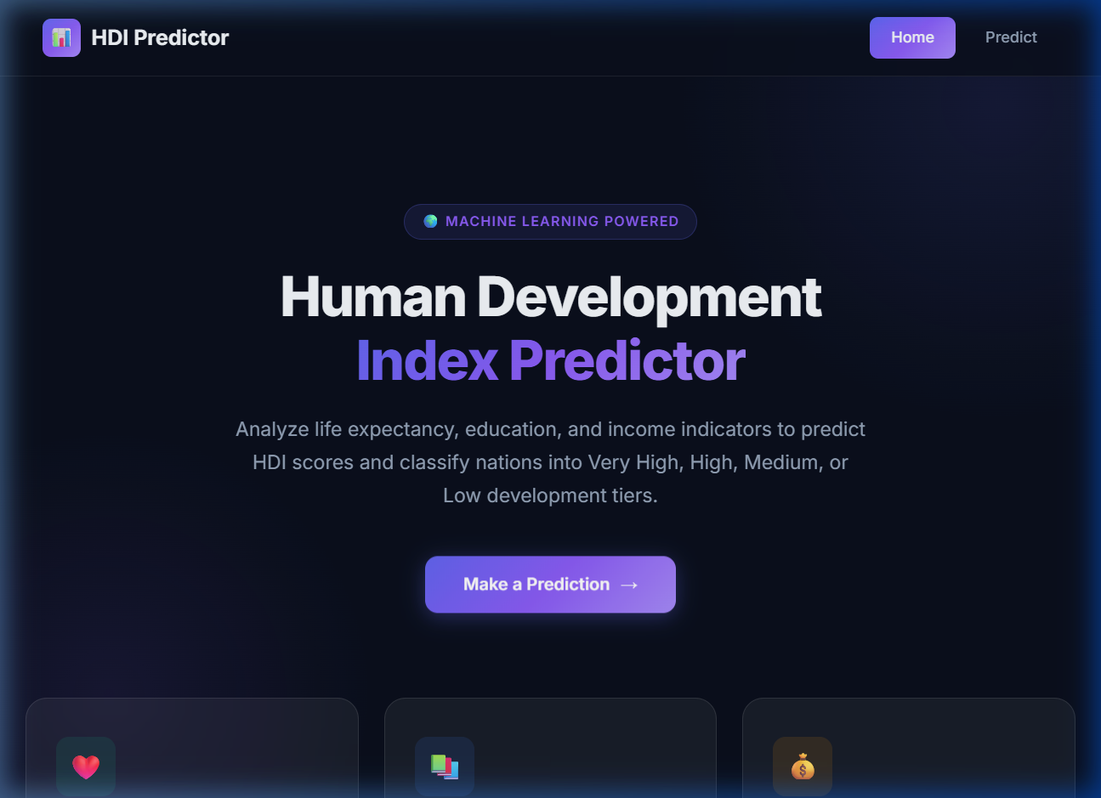
Figure 5.1: Home page of the HDI Prediction Dashboard
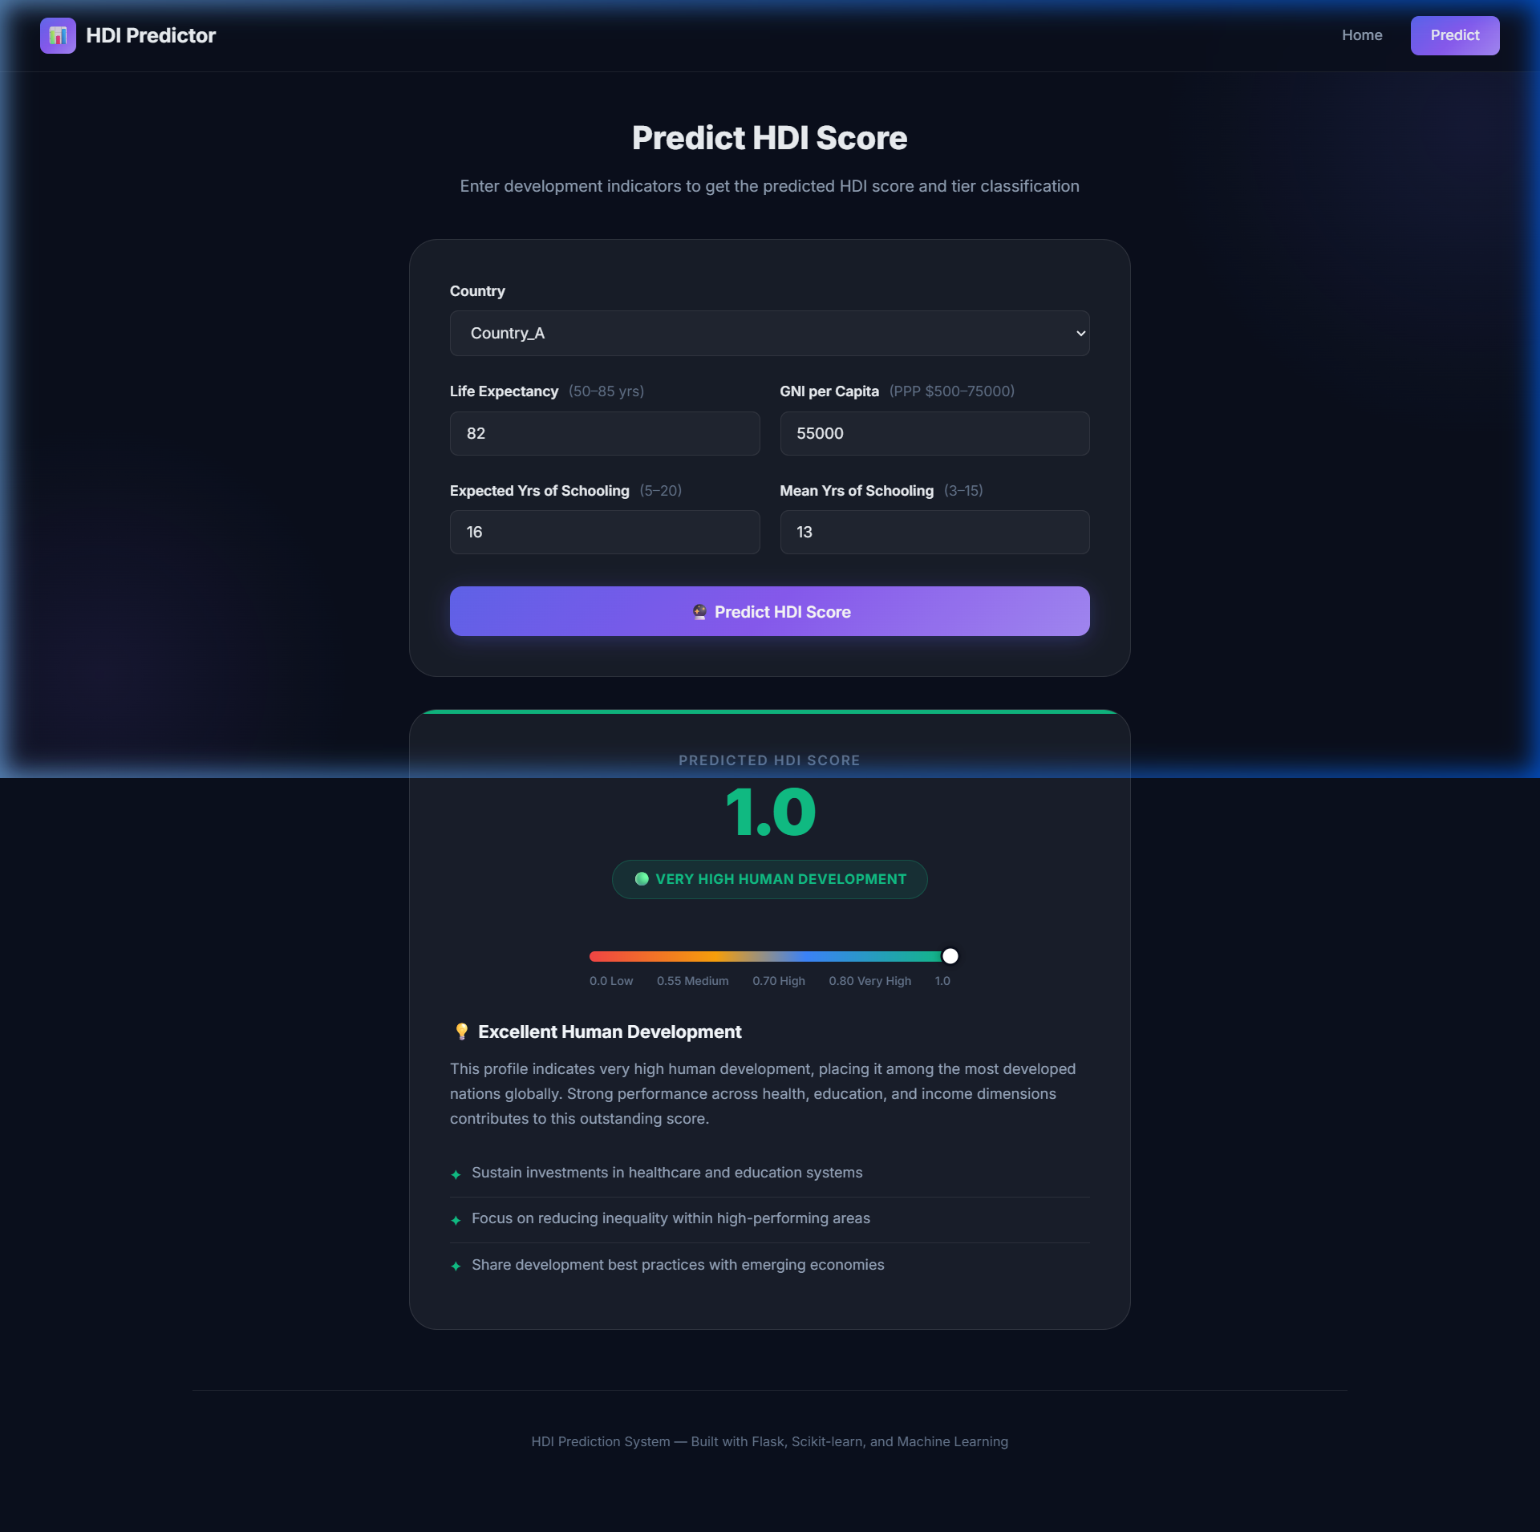
Figure 5.2: User interface for entering country and development parameters

Figure 5.3: Prediction result indicating High Human Development with gauge and recommendations
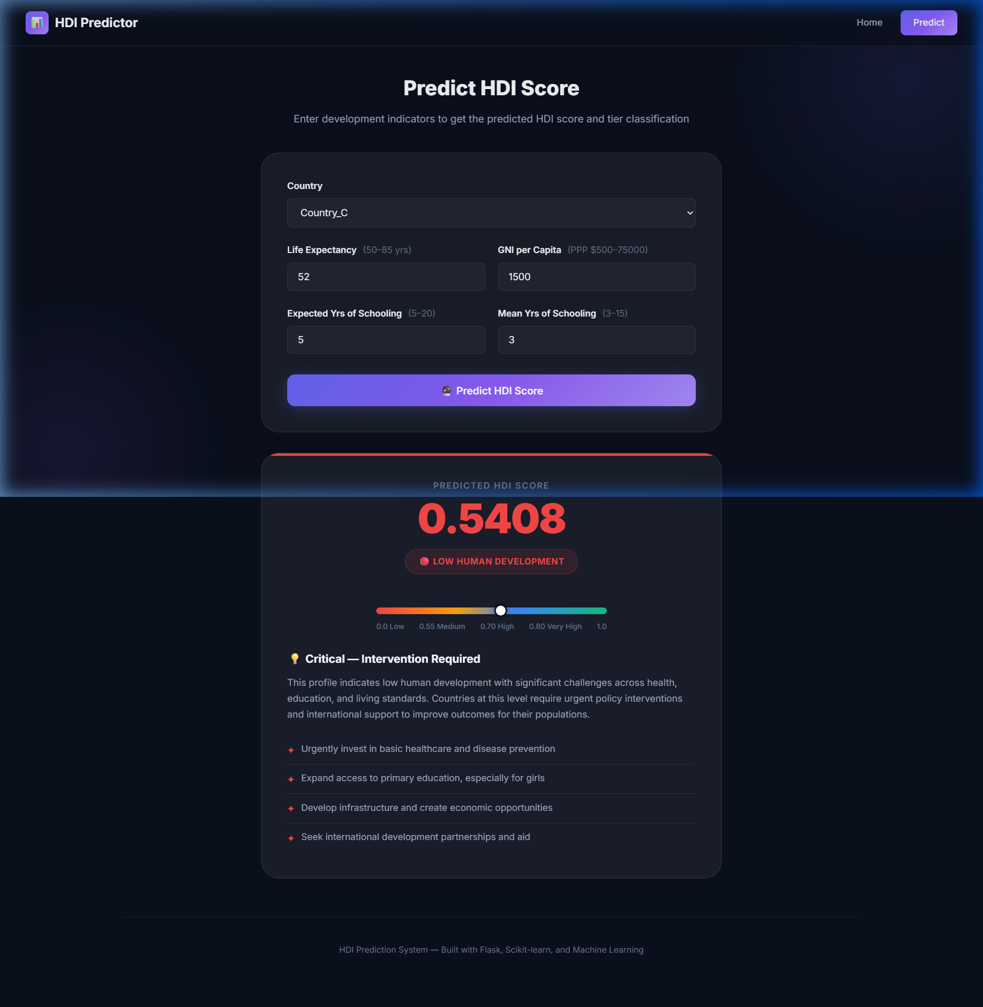
Figure 5.4: Prediction result indicating Low Human Development with gauge and basic recommendations
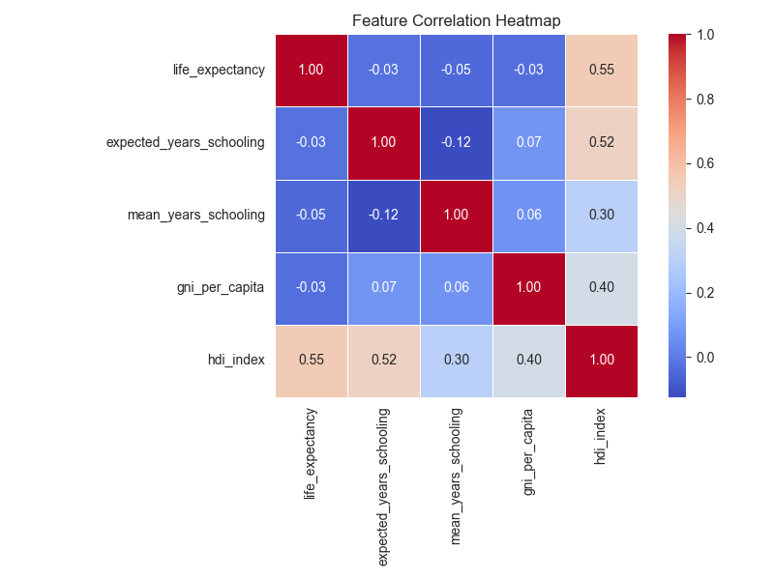
Figure 5.5: Correlation Heatmap of Socio-Economic Features

